Rectangular Parallelepiped

Definition
# Source: AI Source: Provided by: [Data Path: Persons Table -> ID Column: 1, Name_En Column: Motasem Essam] -> From: [ChatGPT] on [7/25/2026]
A rectangular parallelepiped is a three-dimensional geometric solid bounded by six rectangular faces. Each pair of opposite faces is parallel and congruent, and all adjacent faces meet at right angles.
It is a special type of parallelepiped in which all three edge directions are mutually perpendicular.
It is also commonly called a cuboid or a rectangular prism.

Simple Definition
# Source: AI Source: Provided by: [Data Path: Persons Table -> ID Column: 1, Name_En Column: Motasem Essam] -> From: [ChatGPT] on [7/25/2026]
A rectangular parallelepiped is a solid shaped like a box, with six rectangular faces, twelve edges, and eight vertices.
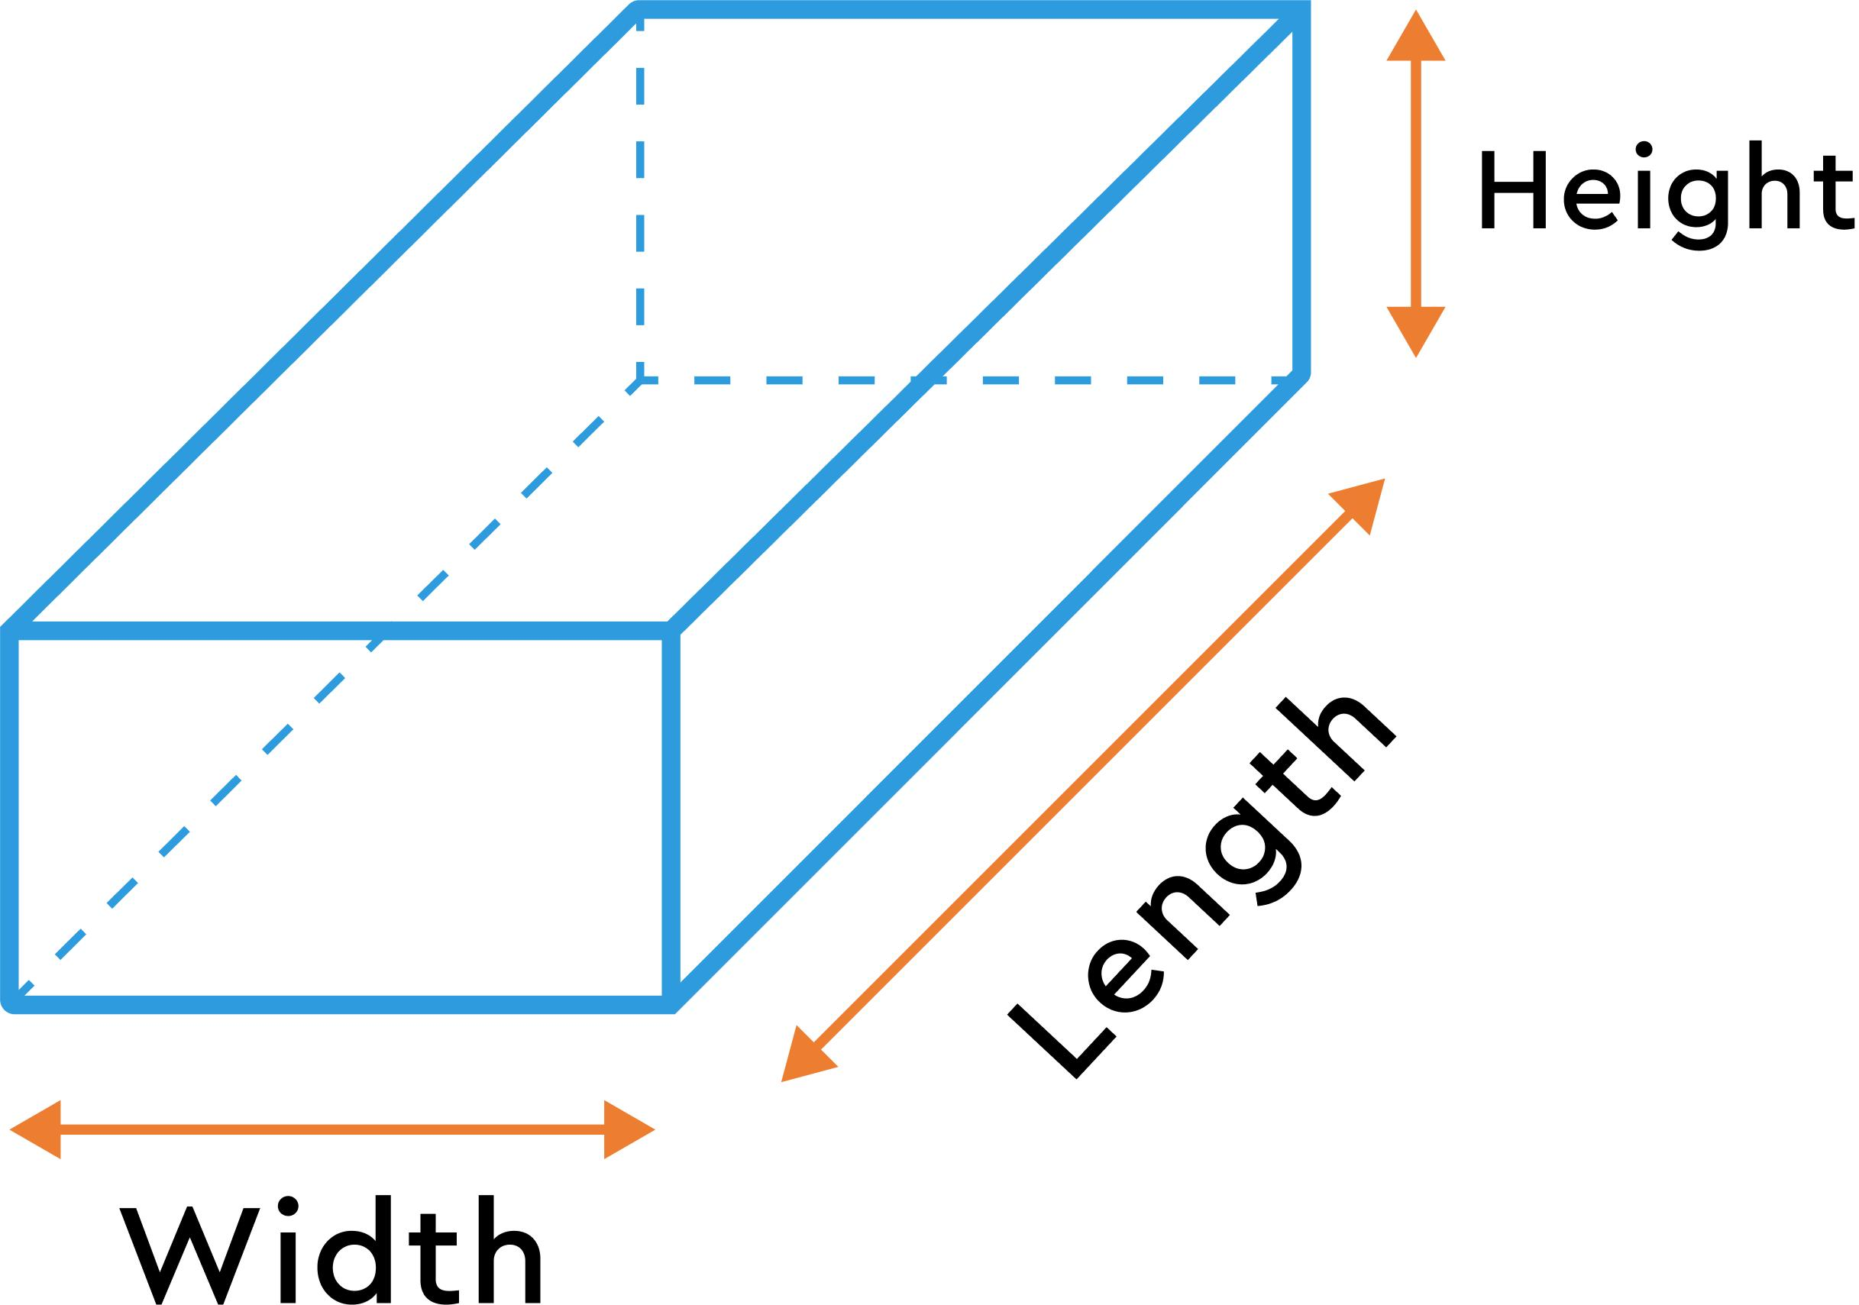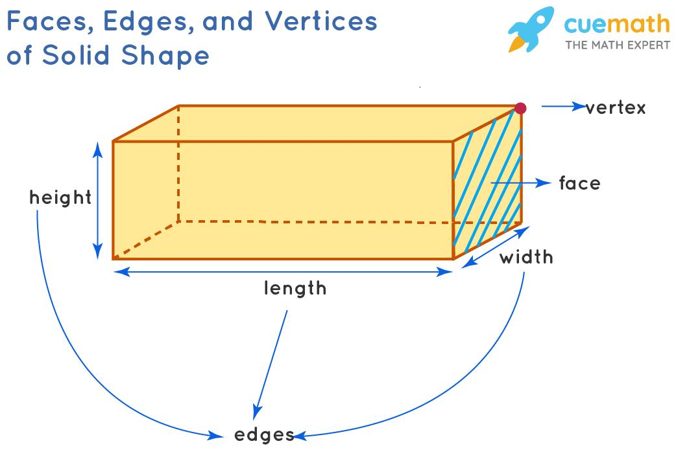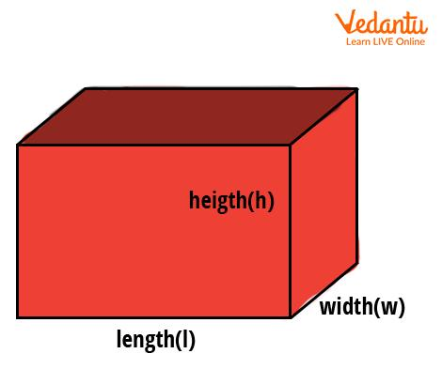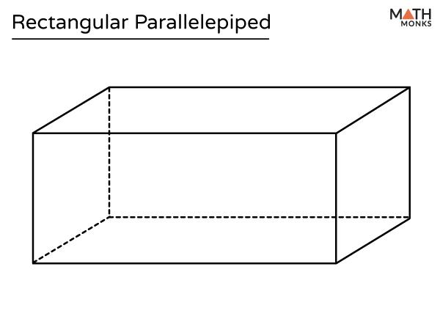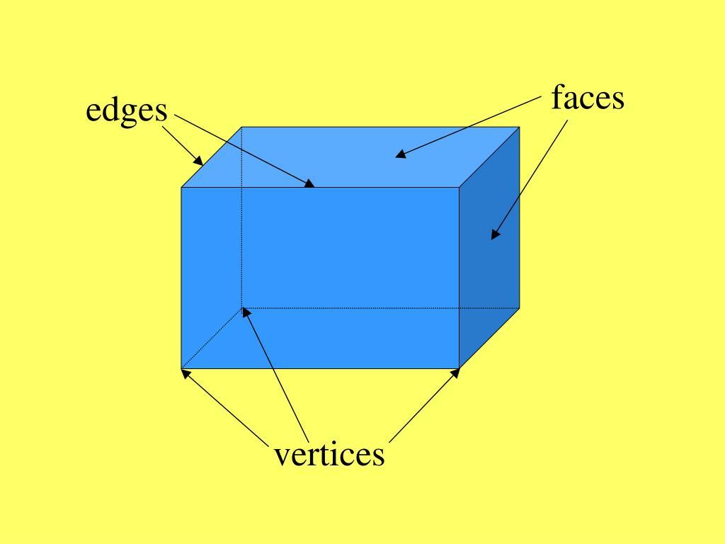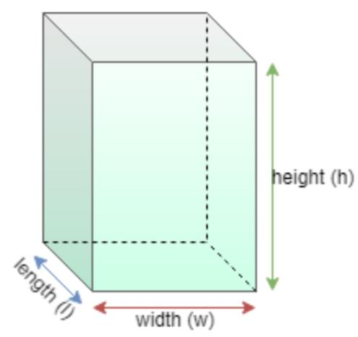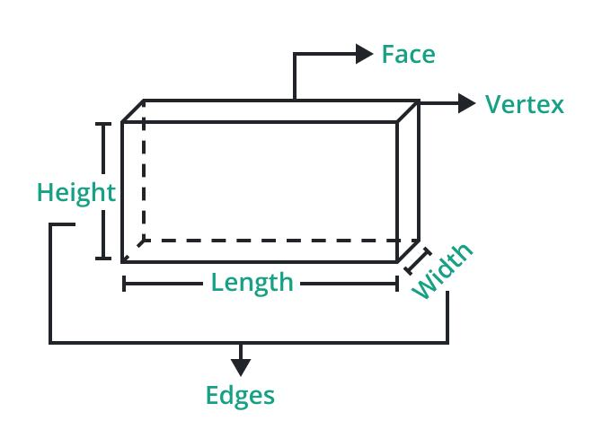

Geometric Structure
# Source: AI Source: Provided by: [Data Path: Persons Table -> ID Column: 1, Name_En Column: Motasem Essam] -> From: [ChatGPT] on [7/25/2026]
A rectangular parallelepiped has the following geometric elements:
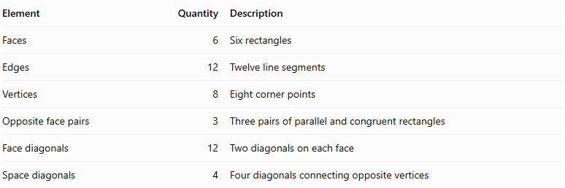
Element | Quantity | Description
Faces | 6 | Six rectangles
Edges | 12 | Twelve line segments
Vertices | 8 | Eight corner points
Opposite face pairs | 3 | Three pairs of parallel and congruent rectangles
Face diagonals | 12 | Two diagonals on each face
Space diagonals | 4 | Four diagonals connecting opposite vertices

Faces
# Source: AI Source: Provided by: [Data Path: Persons Table -> ID Column: 1, Name_En Column: Motasem Essam] -> From: [ChatGPT] on [7/25/2026]
The six faces consist of three pairs of opposite rectangles:
- Top and bottom faces.
- Front and back faces.
- Left and right faces.
Each pair has equal dimensions and area.

Edges
# Source: AI Source: Provided by: [Data Path: Persons Table -> ID Column: 1, Name_En Column: Motasem Essam] -> From: [ChatGPT] on [7/25/2026]
The twelve edges are divided into three groups:
- Four edges of length $l$.
- Four edges of width $w$.
- Four edges of height $h$.

Vertices
# Source: AI Source: Provided by: [Data Path: Persons Table -> ID Column: 1, Name_En Column: Motasem Essam] -> From: [ChatGPT] on [7/25/2026]
The eight vertices are the corners where three edges meet.
Each vertex has three mutually perpendicular edges.

Diagonals
# Source: AI Source: Provided by: [Data Path: Persons Table -> ID Column: 1, Name_En Column: Motasem Essam] -> From: [ChatGPT] on [7/25/2026]
There are two types of diagonals:
- Face diagonals: Connect opposite vertices on the same rectangular face.
- Space diagonals: Connect opposite vertices through the interior of the solid.
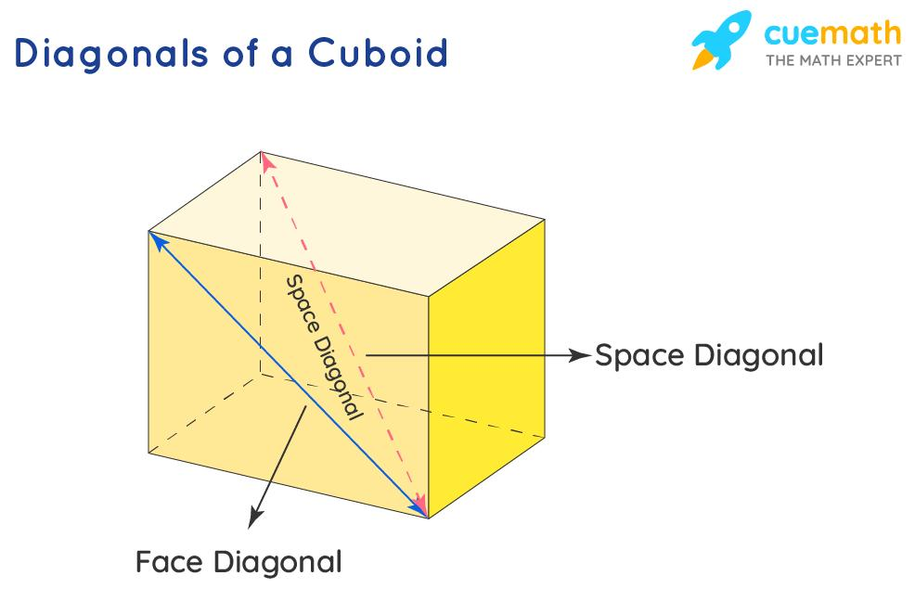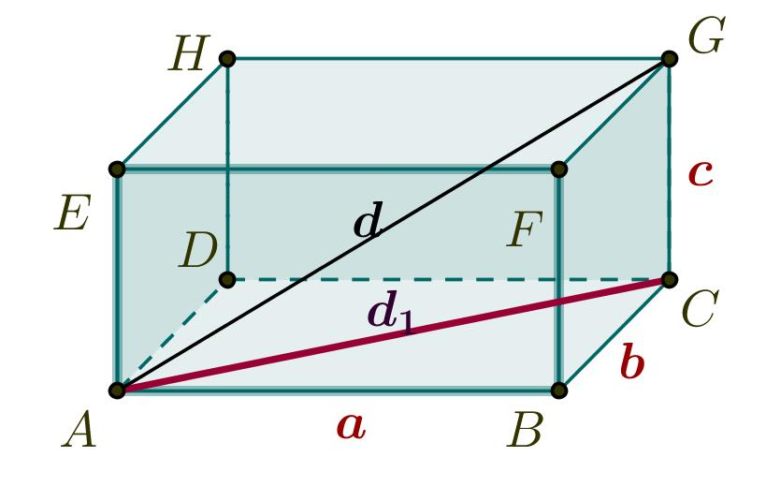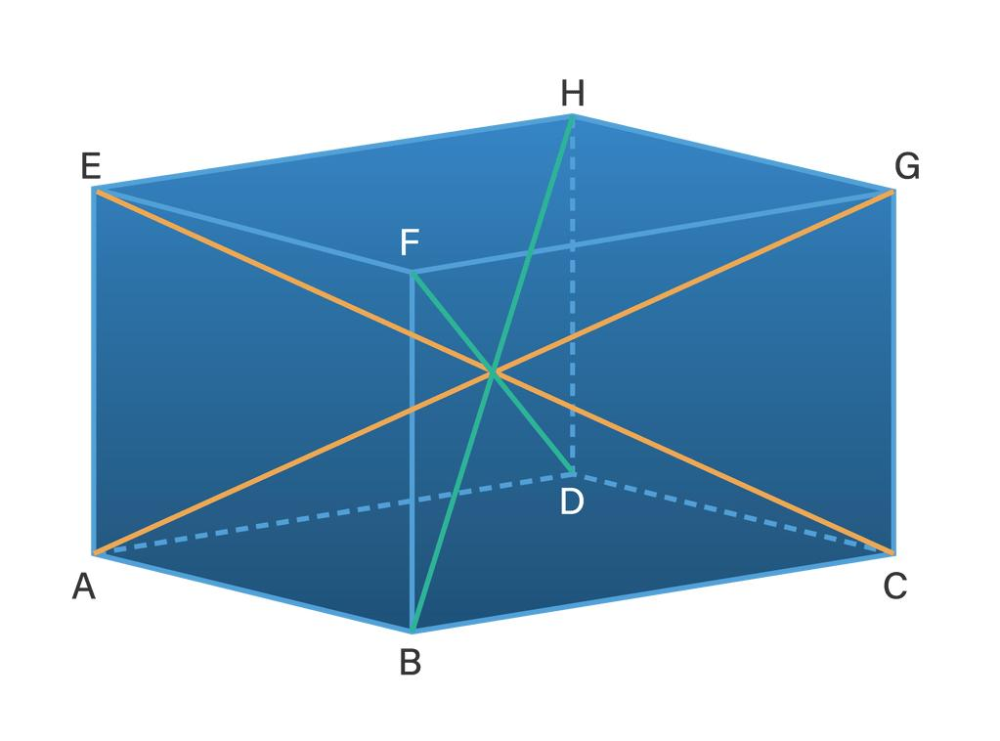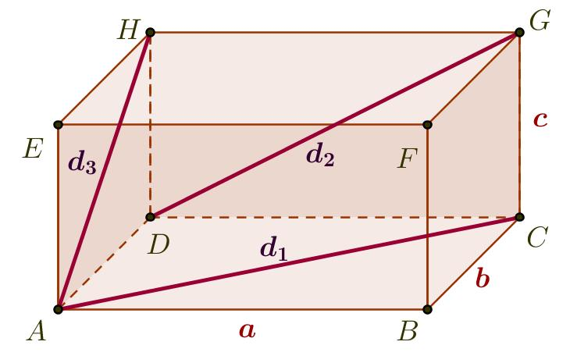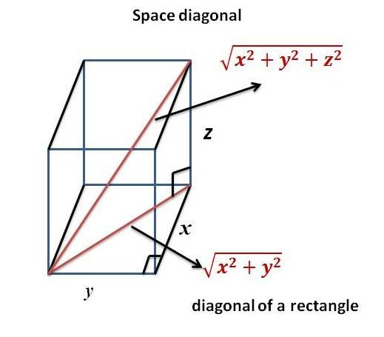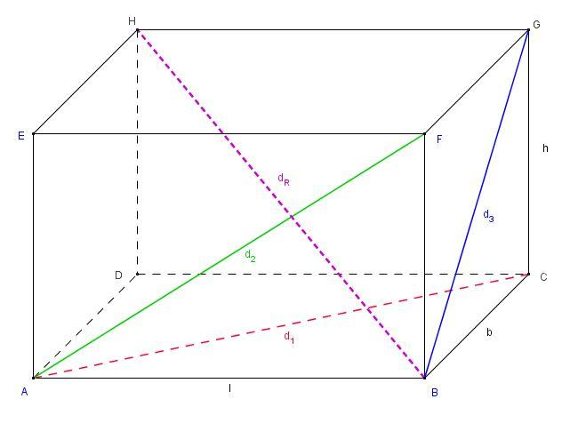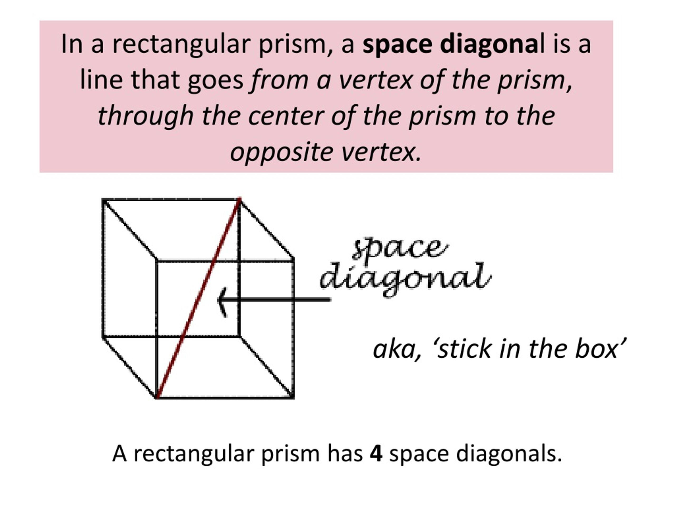

Main Classification of Rectangular Parallelepipeds
# Source: AI Source: Provided by: [Data Path: Persons Table -> ID Column: 1, Name_En Column: Motasem Essam] -> From: [ChatGPT] on [7/25/2026]
Rectangular parallelepipeds can be classified according to the relationships between their three dimensions.

Non-Cubic Rectangular Parallelepiped
# Source: AI Source: Provided by: [Data Path: Persons Table -> ID Column: 1, Name_En Column: Motasem Essam] -> From: [ChatGPT] on [7/25/2026]
A non-cubic rectangular parallelepiped has three mutually perpendicular dimensions, but its three dimensions are not all equal.
$$l,w,h$$
where at least two dimensions differ.
Characteristics:
- Six rectangular faces.
- Three pairs of opposite congruent faces.
- All face angles are ${90}^{∘}$.
- At least two of its dimensions are different.

Cube
# Source: AI Source: Provided by: [Data Path: Persons Table -> ID Column: 1, Name_En Column: Motasem Essam] -> From: [ChatGPT] on [7/25/2026]
A cube is a special rectangular parallelepiped in which all three dimensions are equal.
$$l=w=h=s$$
Characteristics:
- Six congruent square faces.
- Twelve equal edges.
- Eight vertices.
- All face angles are ${90}^{∘}$.
- All space diagonals have equal lengths.
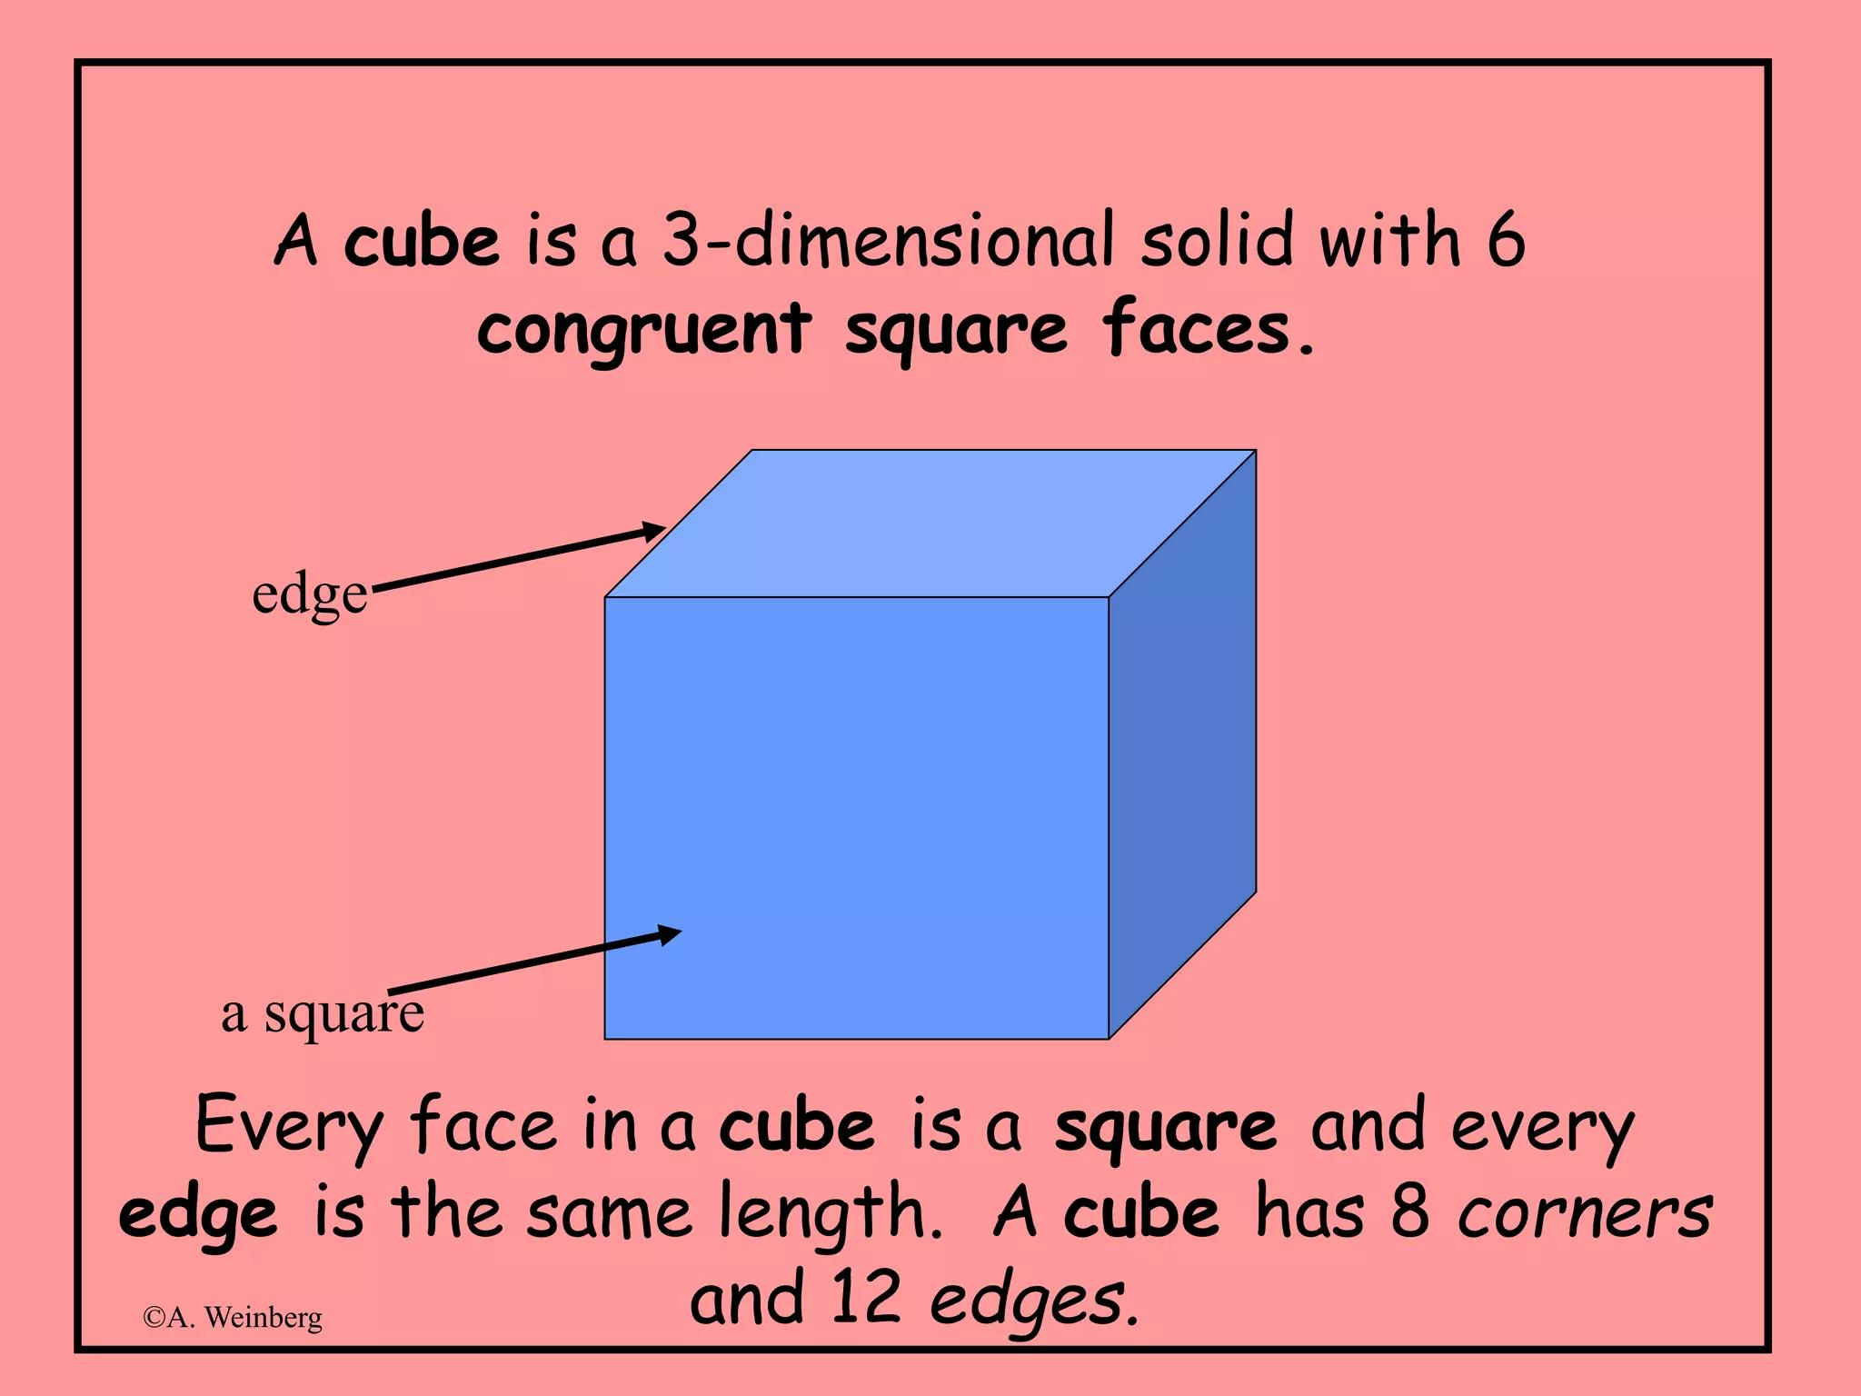
Important distinction: Every cube is a rectangular parallelepiped, but not every rectangular parallelepiped is a cube.

Classification by Dimensional Relationships
# Source: AI Source: Provided by: [Data Path: Persons Table -> ID Column: 1, Name_En Column: Motasem Essam] -> From: [ChatGPT] on [7/25/2026]
A rectangular parallelepiped can also be classified according to the equality or inequality of its length, width, and height.
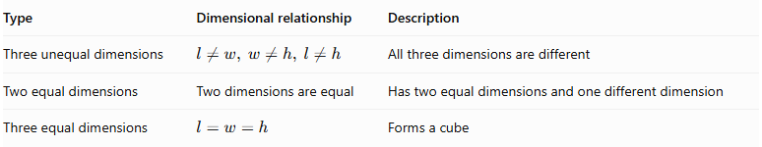
Type | Dimensional relationship | Description
Three unequal dimensions | $$l≠w, w≠h, l≠h$$ | All three dimensions are different
Two equal dimensions | Two dimensions are equal | Has two equal dimensions and one different dimension
Three equal dimensions | $$l=w=h$$ | Forms a cube

Three Unequal Dimensions
# Source: AI Source: Provided by: [Data Path: Persons Table -> ID Column: 1, Name_En Column: Motasem Essam] -> From: [ChatGPT] on [7/25/2026]
$$l≠w, w≠h, l≠h$$
All three dimensions have different lengths.
Example:
$$l=8, w=5, h=3$$

Two Equal Dimensions
# Source: AI Source: Provided by: [Data Path: Persons Table -> ID Column: 1, Name_En Column: Motasem Essam] -> From: [ChatGPT] on [7/25/2026]
Two dimensions are equal, while the third is different.
Examples:
$$l=w≠h$$
$$l=h≠w$$
$$w=h≠l$$

Three Equal Dimensions
# Source: AI Source: Provided by: [Data Path: Persons Table -> ID Column: 1, Name_En Column: Motasem Essam] -> From: [ChatGPT] on [7/25/2026]
All three dimensions are equal.
$$l=w=h$$
This special case is a cube.

Mathematical Properties and Formulas
# Source: AI Source: Provided by: [Data Path: Persons Table -> ID Column: 1, Name_En Column: Motasem Essam] -> From: [ChatGPT] on [7/25/2026]
Let:
- $l$ = length.
- $w$ = width.
- $h$ = height.
- $s$ = edge length of a cube.
- $d$ = space diagonal.

Volume
# Source: AI Source: Provided by: [Data Path: Persons Table -> ID Column: 1, Name_En Column: Motasem Essam] -> From: [ChatGPT] on [7/25/2026]
The volume is the product of the three perpendicular dimensions:
$$\boxed{V=lwh}$$
Unit: cubic units, such as ${cm}^{3}$ or $m^{3}$.

Total Surface Area
# Source: AI Source: Provided by: [Data Path: Persons Table -> ID Column: 1, Name_En Column: Motasem Essam] -> From: [ChatGPT] on [7/25/2026]
The total surface area is the sum of the areas of all six rectangular faces.
$$SA=2lw+2lh+2wh$$
Therefore:
$$\boxed{SA=2(lw+lh+wh)}$$

Lateral Surface Area
# Source: AI Source: Provided by: [Data Path: Persons Table -> ID Column: 1, Name_En Column: Motasem Essam] -> From: [ChatGPT] on [7/25/2026]
If the bottom and top faces are the bases, the lateral surface area consists of the four side faces.
$$LSA=2lh+2wh$$
$$\boxed{LSA=2h(l+w)}$$

Base Area
# Source: AI Source: Provided by: [Data Path: Persons Table -> ID Column: 1, Name_En Column: Motasem Essam] -> From: [ChatGPT] on [7/25/2026]
If the base dimensions are length and width:
$$\boxed{A_{b}=lw}$$

Space Diagonal
# Source: AI Source: Provided by: [Data Path: Persons Table -> ID Column: 1, Name_En Column: Motasem Essam] -> From: [ChatGPT] on [7/25/2026]
The space diagonal connects two opposite vertices through the interior.
Using the three-dimensional Pythagorean theorem:
$$\boxed{d=\sqrt{l^{2}+w^{2}+h^{2}}}$$

Face Diagonals
# Source: AI Source: Provided by: [Data Path: Persons Table -> ID Column: 1, Name_En Column: Motasem Essam] -> From: [ChatGPT] on [7/25/2026]
There are three distinct face-diagonal lengths:
Length-width face:
$$d_{lw}=\sqrt{l^{2}+w^{2}}$$
Length-height face:
$$d_{lh}=\sqrt{l^{2}+h^{2}}$$
Width-height face:
$$d_{wh}=\sqrt{w^{2}+h^{2}}$$
Each of these lengths occurs on two opposite faces.

Mathematical Properties of a Cube
# Source: AI Source: Provided by: [Data Path: Persons Table -> ID Column: 1, Name_En Column: Motasem Essam] -> From: [ChatGPT] on [7/25/2026]
For a cube with edge length $s$:
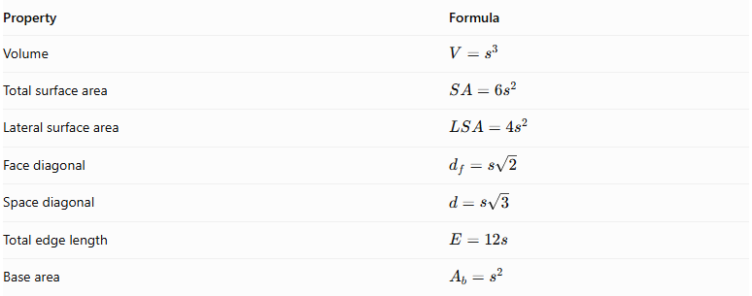
Property | Formula
Volume | $$V=s^{3}$$
Total surface area | $$SA=6s^{2}$$
Lateral surface area | $$LSA=4s^{2}$$
Face diagonal | $$d_{f}=s\sqrt{2}$$
Space diagonal | $$d=s\sqrt{3}$$
Total edge length | $$E=12s$$
Base area | $$A_{b}=s^{2}$$

Worked Examples

Example 1: Calculating the Properties of a Rectangular Parallelepiped
# Source: AI Source: Provided by: [Data Path: Persons Table -> ID Column: 1, Name_En Column: Motasem Essam] -> From: [ChatGPT] on [7/25/2026]
A rectangular parallelepiped has:
- Length = 10 cm.
- Width = 6 cm.
- Height = 4 cm.
Find its volume, total surface area, lateral surface area, and space diagonal.
Step 1: Calculate the volume.
$$V=lwh$$
$$V=10×6×4$$
$$\boxed{V=240{ cm}^{3}}$$
Step 2: Calculate the total surface area.
$$SA=2(lw+lh+wh)$$
$$SA=2(10×6+10×4+6×4)$$
$$SA=2(60+40+24)$$
$$\boxed{SA=248{ cm}^{2}}$$
Step 3: Calculate the lateral surface area.
$$LSA=2h(l+w)$$
$$LSA=2×4(10+6)$$
$$\boxed{LSA=128{ cm}^{2}}$$
Step 4: Calculate the space diagonal.
$$d=\sqrt{l^{2}+w^{2}+h^{2}}$$
$$d=\sqrt{{10}^{2}+6^{2}+4^{2}}$$
$$d=\sqrt{152}$$
$$\boxed{d=2\sqrt{38}≈12.33 cm}$$

Example 2: Calculating the Properties of a Cube
# Source: AI Source: Provided by: [Data Path: Persons Table -> ID Column: 1, Name_En Column: Motasem Essam] -> From: [ChatGPT] on [7/25/2026]
A cube has an edge length of 5 cm.
Find its volume, total surface area, lateral surface area, face diagonal, and space diagonal.
Step 1: Calculate the volume.
$$V=s^{3}$$
$$V=5^{3}$$
$$\boxed{V=125{ cm}^{3}}$$
Step 2: Calculate the total surface area.
$$SA=6s^{2}$$
$$SA=6×5^{2}$$
$$\boxed{SA=150{ cm}^{2}}$$
Step 3: Calculate the lateral surface area.
$$LSA=4s^{2}$$
$$LSA=4×25$$
$$\boxed{LSA=100{ cm}^{2}}$$
Step 4: Calculate the face diagonal.
$$d_{f}=s\sqrt{2}$$
$$\boxed{d_{f}=5\sqrt{2}≈7.07 cm}$$
Step 5: Calculate the space diagonal.
$$d=s\sqrt{3}$$
$$\boxed{d=5\sqrt{3}≈8.66 cm}$$

Important Characteristics
# Source: AI Source: Provided by: [Data Path: Persons Table -> ID Column: 1, Name_En Column: Motasem Essam] -> From: [ChatGPT] on [7/25/2026]
- A rectangular parallelepiped has six rectangular faces.
- Opposite faces are parallel and congruent.
- All face angles are right angles.
- It has twelve edges and eight vertices.
- Its three edge directions are mutually perpendicular.
- It has four space diagonals.
- Its space diagonals are equal in length.
- Its volume is the product of its three dimensions.
- Its total surface area is twice the sum of the three distinct face areas.
- A cube is a special case in which all dimensions are equal.

Comparison with Related Solids
# Source: AI Source: Provided by: [Data Path: Persons Table -> ID Column: 1, Name_En Column: Motasem Essam] -> From: [ChatGPT] on [7/25/2026]
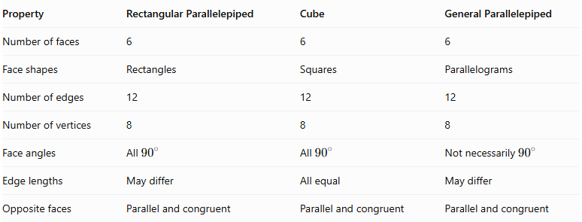
Property | Rectangular Parallelepiped | Cube | General Parallelepiped
Number of faces | 6 | 6 | 6
Face shapes | Rectangles | Squares | Parallelograms
Number of edges | 12 | 12 | 12
Number of vertices | 8 | 8 | 8
Face angles | All ${90}^{∘}$ | All ${90}^{∘}$ | Not necessarily ${90}^{∘}$
Edge lengths | May differ | All equal | May differ
Opposite faces | Parallel and congruent | Parallel and congruent | Parallel and congruent

Constructing Rectangular Parallelepiped in Solid Geometry

Geometric Instruments Used
# Source: AI Source: Provided by: [Data Path: Persons Table -> ID Column: 1, Name_En Column: Motasem Essam] -> From: [ChatGPT] on [7/25/2026]
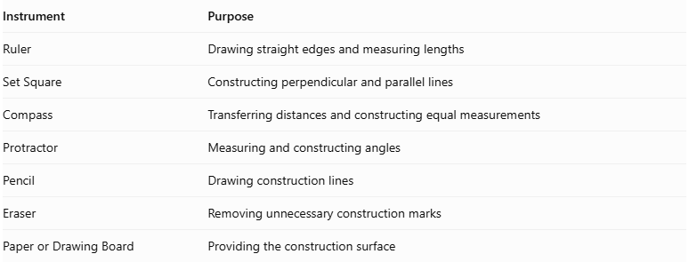
Instrument | Purpose
Ruler | Drawing straight edges and measuring lengths
Set Square | Constructing perpendicular and parallel lines
Compass | Transferring distances and constructing equal measurements
Protractor | Measuring and constructing angles
Pencil | Drawing construction lines
Eraser | Removing unnecessary construction marks
Paper or Drawing Board | Providing the construction surface

Instrument-Based Construction Procedures

Isometric Construction
# Source: AI Source: Provided by: [Data Path: Persons Table -> ID Column: 1, Name_En Column: Motasem Essam] -> From: [ChatGPT] on [7/25/2026]
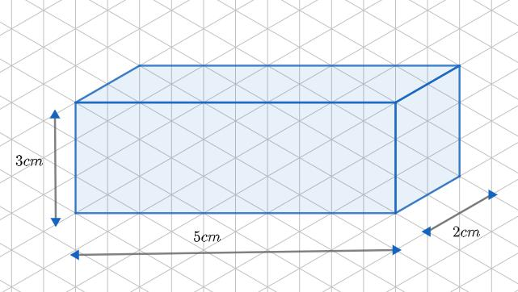
- Draw a horizontal front edge representing the length.
- From its endpoints, draw two parallel receding edges representing the width, using equal isometric angles.
- Complete the parallelogram representing the base.
- Draw vertical edges from the four base vertices to represent the height.
- Connect the upper endpoints to form the top face.
- Complete the remaining edges.
- Distinguish visible edges from hidden edges using solid and dashed lines.

Orthographic Construction
# Source: AI Source: Provided by: [Data Path: Persons Table -> ID Column: 1, Name_En Column: Motasem Essam] -> From: [ChatGPT] on [7/25/2026]
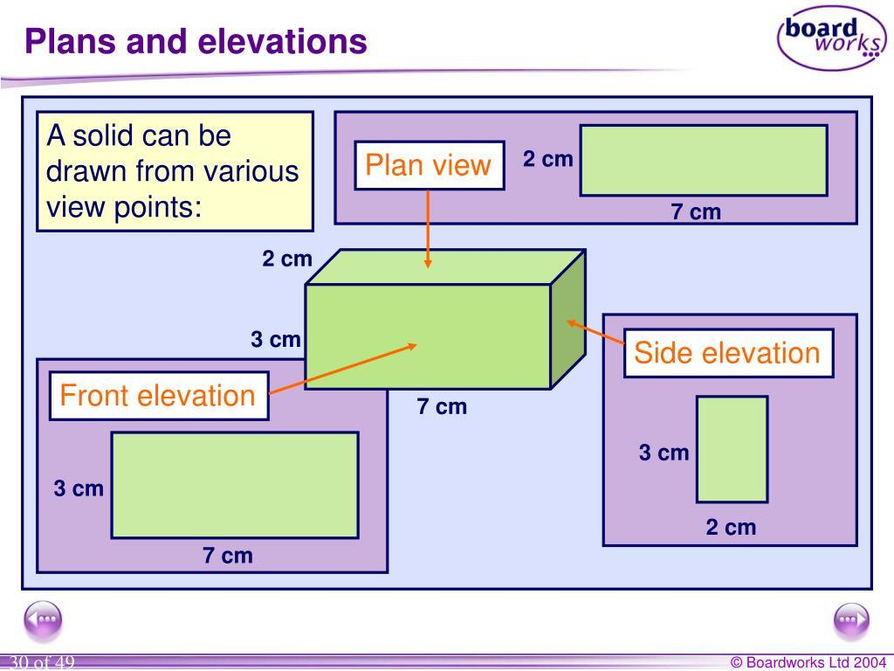
- Draw the front rectangular view using the specified length and height.
- Draw the top rectangular view using the length and width.
- Draw the side rectangular view using the width and height.
- Align corresponding edges between the three views.
- Add dimension lines and labels.

Face-Based Construction
# Source: AI Source: Provided by: [Data Path: Persons Table -> ID Column: 1, Name_En Column: Motasem Essam] -> From: [ChatGPT] on [7/25/2026]
- Construct the rectangular base.
- Construct the opposite rectangular face with equal dimensions.
- Position the two rectangles parallel to one another.
- Connect their corresponding vertices.
- Complete the six rectangular faces.

Edge-Based Construction
# Source: AI Source: Provided by: [Data Path: Persons Table -> ID Column: 1, Name_En Column: Motasem Essam] -> From: [ChatGPT] on [7/25/2026]
- Draw one rectangular face.
- Construct the four connecting edges perpendicular to that face.
- Make the connecting edges equal to the required height.
- Connect their endpoints to form the opposite rectangular face.
- Complete and check all edges.

Net-Based Construction
# Source: AI Source: Provided by: [Data Path: Persons Table -> ID Column: 1, Name_En Column: Motasem Essam] -> From: [ChatGPT] on [7/25/2026]
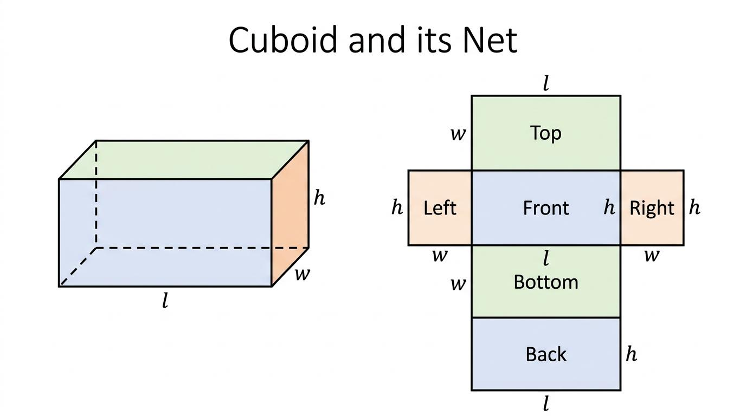
- Draw four rectangles connected in a strip to form the lateral faces.
- Attach two congruent rectangles to appropriate edges to represent the top and bottom faces.
- Check that the dimensions of adjoining faces match.
- Add tabs if the net is intended for physical assembly.
- Fold the net along its edges to form the rectangular parallelepiped.

Real-World Applications
# Source: AI Source: Provided by: [Data Path: Persons Table -> ID Column: 1, Name_En Column: Motasem Essam] -> From: [ChatGPT] on [7/25/2026]
Rectangular parallelepipeds are common in everyday objects and engineering.
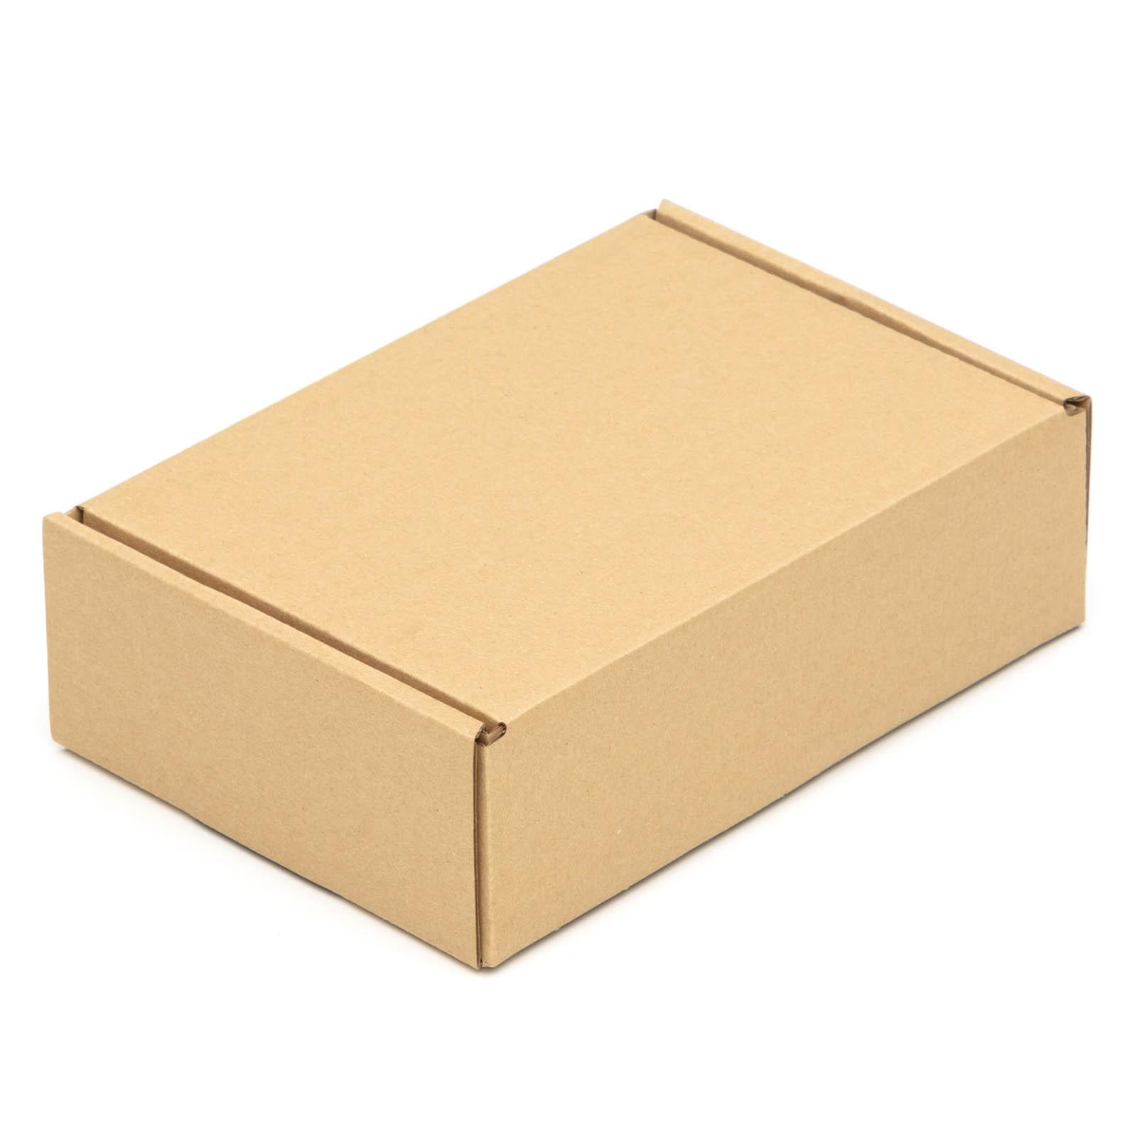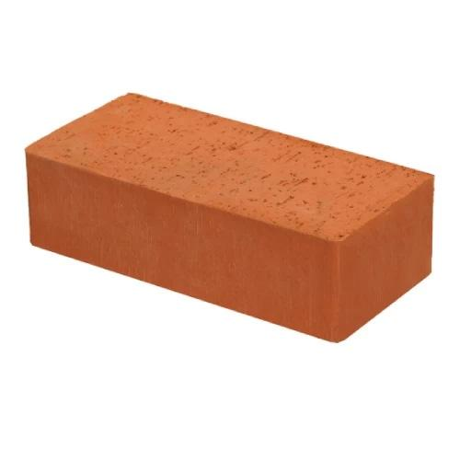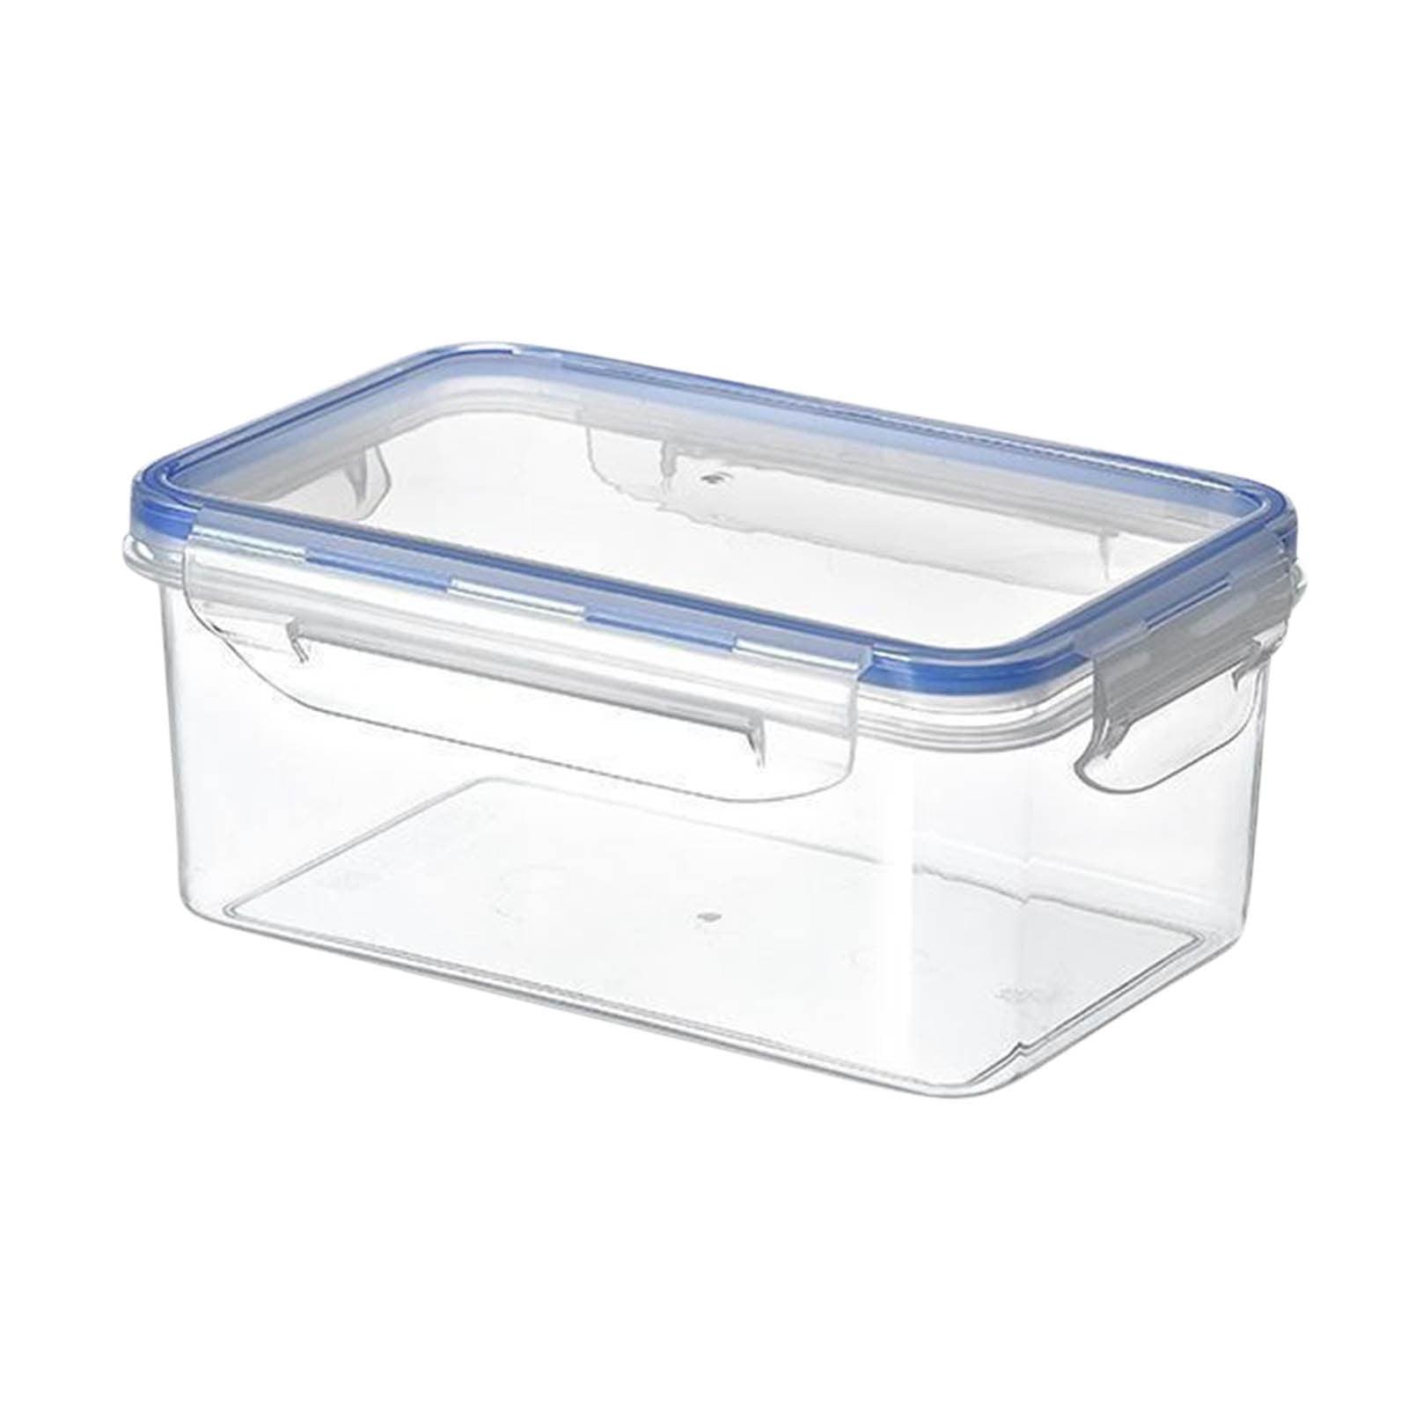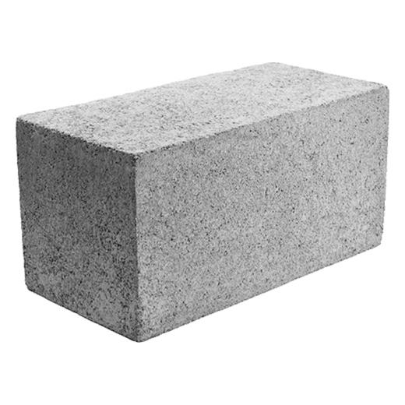
Examples include:
- Boxes: Packaging and shipping containers.
- Bricks: Rectangular construction blocks.
- Storage containers: Storage and organization systems.
- Building blocks: Structural and architectural components.
- Furniture: Cabinets, drawers, and rectangular tables.
- Engineering: Mechanical components and rectangular enclosures.

Key Points
# Source: AI Source: Provided by: [Data Path: Persons Table -> ID Column: 1, Name_En Column: Motasem Essam] -> From: [ChatGPT] on [7/25/2026]
- A rectangular parallelepiped is a solid bounded by six rectangles.
- It is also called a cuboid or rectangular prism.
- It has 6 faces, 12 edges, and 8 vertices.
- Opposite faces are parallel and congruent.
- All adjacent faces meet at right angles.
- Its three dimensions are length, width, and height.
- Its volume is $lwh$.
- Its total surface area is $2(lw+lh+wh)$.
- Its space diagonal is $\sqrt{l^{2}+w^{2}+h^{2}}$.
- A cube is a special rectangular parallelepiped.

Conclusion
# Source: AI Source: Provided by: [Data Path: Persons Table -> ID Column: 1, Name_En Column: Motasem Essam] -> From: [ChatGPT] on [7/25/2026]
A rectangular parallelepiped is a fundamental three-dimensional geometric solid characterized by six rectangular faces, twelve edges, and eight vertices. Its three dimensions—length, width, and height—are mutually perpendicular. It includes non-cubic forms and the special case of a cube. Its geometric properties and formulas are widely used in geometry, measurement, engineering, architecture, and everyday applications.

